TEMASEK POLYTECHNIC
SCHOOL OF INFORMATICS & IT
DIPLOMA IN INFOCOMM AND DIGITAL MEDIA

AY 2024/2025 October Semester

Case Study / Project
Case Study / Project Presentation

SERVERS ADMINISTRATION & SECURITY (CIML010)
SUBJECT LEVEL: NA

GENERAL INSTRUCTIONS

1. This Case Study / Project / Project presentation consists of 13 pages (including cover page) and carries 65% of the SADS subject.

2. Please complete ALL tasks in this assignment.

Content

1. Assessment scores 3
2. Project (65%) 3
Main tasks in this project 3
3. Individual VM Setup and Configuration (22%) 4
4. Group Research Report (10%) 9
5. Group Presentation (10%) and Individual Demonstration/Q&A (15%) 9
6. Deliverables 10
7. Late submissions 10
8. Feedback and questions 10
9. Conduct 10
Appendix A – Declaration of Non-Plagiarism 11

Assessment scores

This is case study/project contributes 65% for the SADS subject. Following are the assessment components:

Assessments | Marks awarded for individual work | Marks awarded for group work
Weekly quizzes | 8% | -
Submission of Individual VirtualBox VM | 22% | -
Group Setup and Configuration | - | 10%
Group Presentation | - | 10%
Individual Presentation | 15% | -
Total | 45% | 20%

Project (65%)

Main tasks in this project

A) Completion of Weekly Quizzes (8%). Complete weekly quizzes posted on Politemall.

B) Individual VM Setup and Configuration (22%) – please refer to section 3 for details.

In this project, you will make use of the Linux System administration and security configuration knowledge and skills acquired from the subject to:
- Install a Linux virtual machine configured with the mandatory project required features (from task 3.1 – 3.6)

C) Group Research Report (10%) – please refer to section 4 for details

In the group work portion of the project, each group will select and research one of 4 research topics.

D) Group Presentation (10%) and Individual Demonstration (15%) – please refer to section 5 for details

As a group, you will then conduct a presentation (with slides) of the research topic that your group has selected in C.

Individual VM Setup and Configuration (22%)

The following sections from 3.1 to 3.6 list the mandatory setup, installation and configuration steps that all students must complete on an individual basis.

3.1 Install a clean copy of a Linux operating system [setup will be demonstrated in class]

- You may choose to setup using Cent OS (version 9 stream – iso provided).

- The operating system should be setup either in Oracle Virtual Box using the following parameters:
- CPU 1 or more
- Memory 2GB or more
- Hard disk drive 32GB or more
- Hard disk space should be dynamically allocated as the requirements increase (capped at the storage capacity specified in item iii)
- Hard disk storage type can be VDI or VMDK

- The operating system should be setup to boot up in Graphical User Interface (GUI) mode.

- The hard disk should be partitioned during installation according to the following:
Mount Point | Size | Partition Type | File System | Options
/boot | 1GiB | Linux | ext4 | defaults
/var | 2GiB | Linux | ext4 | defaults
/home | 2GiB | Linux | ext4 | defaults
Swap | 1GiB | Linux Swap | swap | defaults
/tmp | Refer to table below | Linux | ext4 | defaults
/nfsshare | Refer to table below | Linux | ext4 | defaults
/ | Rest of hard disk space | Linux | ext4 | defaults

The /tmp and /nfsshare partitions listed above are to be created according to the following sizes. Use the partition sizes indicate beside your class register number. Your tutor will share your register number in class.
Class register number | /tmp partition size (MiB) | /nfsshare partition size (MiB)
01 | 100 | 2900
02 | 200 | 2800
03 | 300 | 2700
04 | 400 | 2600
05 | 500 | 2500
06 | 600 | 2400
07 | 700 | 2300
08 | 800 | 2200
09 | 900 | 2100
10 | 1000 | 2000
11 | 1100 | 1900
12 | 1200 | 1800
13 | 1300 | 1700
14 | 1400 | 1600
15 | 1500 | 1500
16 | 1600 | 1400
17 | 1700 | 1300
18 | 1800 | 1200
19 | 1900 | 1100
20 | 2000 | 1000
21 | 2100 | 900
22 | 2200 | 800
23 | 2300 | 700
24 | 2400 | 600
25 | 2500 | 500
26 | 2600 | 400
27 | 2700 | 300
28 | 2800 | 200
29 | 2900 | 100

- Setup the root password to Passw0rd$ and an additional user account named student with password Passw0rd$.

- Setup the timezone to local time zone (GMT+8), language to US English or UK English and keyboard to US.

After successfully setting up the Linux operating system virtual machine, you are highly recommended to create a snapshot of your virtual machine and/or export it to store as a backup in case of emergency.

3.2 Creating/mounting an LVM device
Relevant Topics
Creating Partitions
Mounting Partitions

- Add two 1GB hard disks to the Linux VM.
- Create the following partitions:
Device | Size | Partition Type
/dev/sdb1 | 450MiB | Linux LVM
/dev/sdb2 | Balance of disk space | Linux LVM
/dev/sdc1 | 550MiB | Linux LVM
/dev/sdc2 | Balance of disk space | Linux LVM

# refers to your class register number

Volume Group 1
- Using /dev/sdb1 and /dev/sdc1, create a volume group named “sadsvg#1” with a physical extent size being 8MiB.
- Create LVM “sadslv#1A” with a size of 75 logical extents (600MiB).
- Create another LVM “sadslv#1B” using the available disk space on “sadsvg#1”.
- Format both LVMs using ext4.
- Mount the LVMs at /mnt/sadslv#1A and /mnt/sadslv#1B persistently and set the mount options to be “defaults”.

Volume Group 2
- Using /dev/sdb2 and /dev/sdc2, create a volume group named “sadsvg#2” with default physical extent size.
- Create LVM “sadslv#2A” with a size of 200MiB
- Create another LVM “sadslv#2B” using the available disk space on “sadsvg#2”.
- Format both LVMs using ext4.
- Mount the LVMs at /mnt/sadslv#2A and /mnt/sadslv#2B persistently and set the mount options to be “defaults”.

3.3 Create the following groups and users
Relevant Topics
Configuring the Shell
User and Group Accounts

# refers to your class register number

User Name | UID | GID | Secondary group |  | Home Directory | Shell | Comments | Umask
manager# | 1200 | 2000 | managers#  lecturers#  wheel | /home/academia#/manager# |  | bash | diploma manager# | 0077
teacher#1 | 1201 | 2000 | lecturers#  wheel | /home/academia#/teacher#1 |  | bash | diploma staff #1 | 0077
teacher#2 | 1202 | 2000 | lecturers#  wheel | /home/academia#/teacher#2 |  | bash | diploma staff #2 | 0077
student#1 | 1001 | 1500 | NA | /home/students#/student#1 |  | bash | diploma student #1 | 0022
student#2 | 1002 | 1500 | NA | /home/students#/student#2 |  | bash | diploma student #2 | 0022
student#3 | 1003 | 1500 | NA | /home/students#/student#3 |  | bash | diploma student #3 | 0027
student#4 | 1004 | 1500 | NA | /home/students#/student#4 |  | bash | Diploma  student #4 | 0027

Group Name | GID | Primary members | Secondary members
students# | 1500 | student#1, student#2, student#3, student#4 | NA
academia# | 2000 | manager#  teacher#1  teacher#2 | NA
managers# | 2001 | - | manager#
lecturers# | 2002 | - | manager#  teacher#1  teacher#2

All the user accounts password should be set to Passw0rd$.

3.4 Install additional software packages
Relevant Topics
Package Management

- Install the Very Secure File Transfer Protocol (vsftpd) daemon
- Ensure that the vsftpd daemon process is automatically started every time the server reboots.

3.5 Create the folder structure, ownership and permission
Relevant Topics
File Manipulation
File Searching
Text Manipulation
Regular Expressions
Redirection
File Permissions

# refers to your class register number

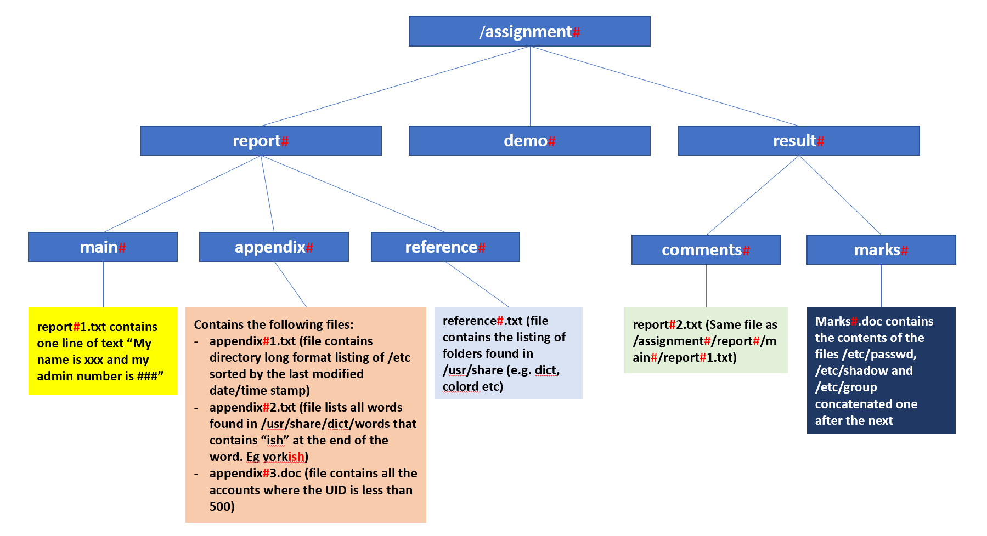
Figure 1: Folder Structure for SADS Case Study

Please note that the assignment folder and all subfolders depicted in figure 1 is to be created under the “/” folder and not in the “/root” folder.

Set the ownership and permission structure of the folder structure to the below:
Directory/file | User Owner | Group Owner | Permission
/assignment# | manager# | academia# | drwxrws---
/assignment#/report#/ | student#1 | students# | drwxrwx-w-
/assignment#/report#/main#/ | student#2 | students# | drwxrwx-wT
/assignment#/report#/main#/report#1.txt | student#2 | students# | -rw-rw-r--
/assignment#/report#/appendix#/ | student#3 | students# | drwxrwx-wT
/assignment#/report#/appendix#/appendix#1.txt  /assignment#/report#/appendix#/appendix#2.txt  /assignment#/report#/appendix#/appendix#3.doc | student#3 | students# | -rw-rw-r--
/assignment#/report#/reference#/ | student#1 | students# | drw-rw-r--
/assignment#/report#/reference#/reference#.txt | student#4 | students# | -rw-rw-r--
/assignment#/demo#/ | teacher#1 | academia# | drwxr-x--x
/assignment#/result#/ | teacher#2 | academia# | drwxr-x---
/assignment#/result#/comments#/ | teacher#2 | academia# | drwxr-x---
/assignment#/result#/marks#/ | teacher#2 | academia# | drwxr-x---
/assignment#/result#/comments#/report#2.txt | teacher#2 | academia# | -rw-r-----
/assignment#/result#/marks#/Marks#.doc | teacher#2 | academia# | -rw-r-----

3.6 Schedule cron jobs
Relevant Topics
Regular Expressions
Archive Commands
Scheduling Jobs

# refers to your class register number

Schedule the following system cronjob

Schedule | User | Job Requirement
Runs on the 10th day of every month at 1am | root | Backup the entire /etc folder to an archive file named “backup-etc-YYYYMM.tar.gz” to the /mnt/sadslv#2B folder where YYYY is the 4 digit year and MM is the 2 digit month. For eg, if the job was run on 10th January 2019 at 1am, the archive file name will be “backup-etc-201901.tar.gz.

Group Research Report (10%)

4.1 Your group (either 5 or 6 students) shall select one of the following advanced Linux topics and research on the installation, configuration and testing based on the following topology:

- Automating Linux Server management using Ansible
- Running Apache Web Server as container (with persistent mounting)
- Implement a site-to-site Virtual Private Network (VPN) between two Linux Servers
- Lightweight Directory Access Protocol (LDAP) Service

4.2 Group Report

The group shall document a step-by-step configuration guide (report) for the selected topic of research in a group research report. The document should include appropriate screen captures of configuration files and explanation of settings. Typical sections in the report could include (but not limited to) the following:
- Declaration of Non-Plagiarism (Appendix A)
- Introduction
- Benefits/Problem Solved by Technology
- Installation, Configuration and Test Scenarios
- Conclusion
- References

You can assume that the target audience of your report is already familiar with the Linux operating system.

Group Presentation (10%) and Individual Q&A (15%)

Each group shall conduct a slides presentation (under 20 minutes) of the research topic in section 4. The following is a guideline of the presentation / Q&A flow:
- Research topic (20 minutes each group)
  - Introduction
  - Sharing the Benefits/Problem Solved by Technology
  - Demonstration
  - Conclusion
- Q&A of research topic (5-10 minutes per student)

Deliverables

Week 13

- Complete all PoliteMALL Quizzes by 17 January 2025 2200 hrs.

Week 14
- Individual VM submission in PoliteMALL by 24 January 2025 2200 hrs. All VMs to be named STEPID-Name-October24.ova.

Week 18
- Group report submission in PoliteMALL by 21 February 2025 2200 hrs.
- Group presentation via HBL.

All submission links will be made available in PoliteMALL within one week from the submission due date.

Late submissions

Late submissions will attract penalties:
- Late and < 1 day – 10% deduction from absolute marks given for the part of the work e.g. if the assignment was worth 100 marks, you were given 75 marks for the work, after the penalty you are left with 65 marks i.e. 75 – 100x10%
- Late >= 1 and < 2 days – 20% deduction from absolute marks
- Late >= 2 days – no marks will be awarded

Feedback and questions

You are encouraged to obtain feedback from your tutors and ask questions related to the requirements of the Project.

Conduct

Be warned that students caught plagiarising will have serious consequences.

Appendix A – Declaration of Non-Plagiarism

Servers Administration and Security (CIML010)
Group Research Report

Submitted by: <Matric Number> <Full Name of student>
Submitted by: <Matric Number> <Full Name of student>
Submitted by: <Matric Number> <Full Name of student>
Submitted by: <Matric Number> <Full Name of student>
Submitted by: <Matric Number> <Full Name of student>
Submitted by: <Matric Number> <Full Name of student>

Date: dd /mm/yyyy

“By submitting this work, I am / we are declaring that I am / we are the originator(s) of this work and that all other original sources used in this work has been appropriately acknowledged.

I / We understand that plagiarism is the act of taking and using the whole or any part of another person’s work and/or the work generated by Artificial Intelligence presenting it as my/ our own without proper acknowledgement.

I / We also understand that plagiarism is an academic offence and that disciplinary action will be taken if I am found to have committed or abetted the offence of plagiarism.”

Name and Signature of student: ……………………………………
Name and Signature of student: ……………………………………
Name and Signature of student: ……………………………………
Name and Signature of student: ……………………………………
Name and Signature of student: ……………………………………
Name and Signature of student: ……………………………………

Declaration on the use of Generative AI tools for assignments

Describe how you have used Generative AI tools such as ChatGPT or Dall.E-2 in your assignment.

Show snapshots of the conversations with the AI tool (i.e., the prompts you used and the response you get from the AI tool).

How to indicate the reference?
The content generated by AI tools are not retrievable except by the user who generated them, so they are considered non-recoverable sources. For non-recoverable sources:
- do not include in a reference list
- cite within the text as personal communications or correspondence
Based on APA 7th edition referencing format,
(Communicator, personal communication, Month Day, year)

E.g. (Paraphrase from OpenAI's ChatGPT AI language model, personal communication, March 8, 2023).

Important Note:

- Do not copy answers produced by the AI tool in totality as it is considered as plagiarism.

- Do not rely on any information produced by the AI tool blindly. You should always verify the answer with other sources. Do not assume that these answers provided by the AI tool are correct.

- To achieve quality outputs from the AI tool, you should provide good prompt that is clear and specific. Be precise and provide context. Avoid asking open-ended questions.

